UUID: VAN0010-LK-160-2 VAN0010-LK-160-2_HBM833.DBGG.252

Patient #: 67112

Internal #: 92

A, S, R: 56, M, W

Laterality: Left

(Right, Left)

Anatomical Location: Lower

(U, M, L, N/A)

Dimensions: 35x19x3

(in mm)

Distance from Tumor: 5

(in cm)

Image:

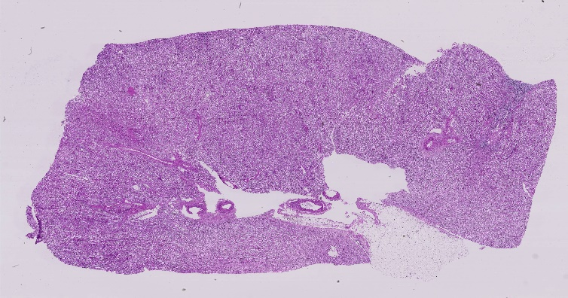UUID: VAN0011-RK-8-2 VAN0011-RK-8-2_HBM783.GJWP.694

Patient #: 67177

Internal #: 95

A, S, R: 31, M, W

Laterality: R

(Right, Left)

Anatomical Location: Lower

(U, M, L, N/A)

Dimensions: 25x15x4

(in mm)

Distance from Tumor: N/A

(in cm)

Image:

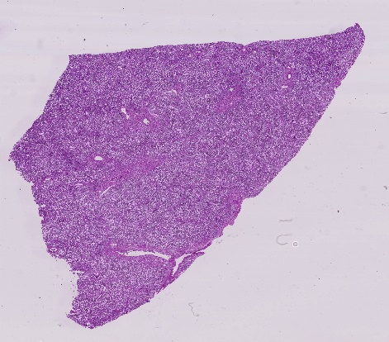

UUID: VAN0013-LK-206-2 VAN0013-LK-206-2_HBM623.RPMC.638

Patient #: 68304

Internal #: 125

A, S, R: 61, F, W

Laterality: Left

(Right, Left)

Anatomical Location: Lower

(U, M, L, N/A)

Dimensions: 17 x 16 x 4

(in mm)

Distance from Tumor: N/A

(in cm)

Image:

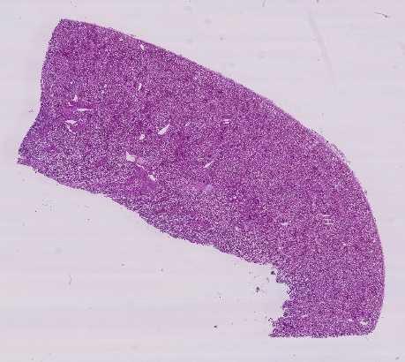

UUID: VAN0014-LK-207-2 VAN0014-LK-207-2_HBM276.PGFS.693

Patient #: 68555

Internal #: 130

A, S, R: 76, F, W

Laterality: Left

(Right, Left)

Anatomical Location: Lower

(U, M, L, N/A)

Dimensions: 20 x 14 x 5

(in mm)

Distance from Tumor: N/A

(in cm)

Image:

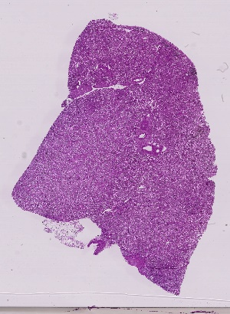

UUID: VAN0016-LK-208-2 VAN0016-LK-208-2_HBM676.SNVK.793

Patient #: 66999

Internal #: 133

A, S, R: 56, M, W

Laterality: Left

(Right, Left)

Anatomical Location: Upper

(U, M, L, N/A)

Dimensions: 33 x 23 x 4

(in mm)

Distance from Tumor: 3

(in cm)

Image:

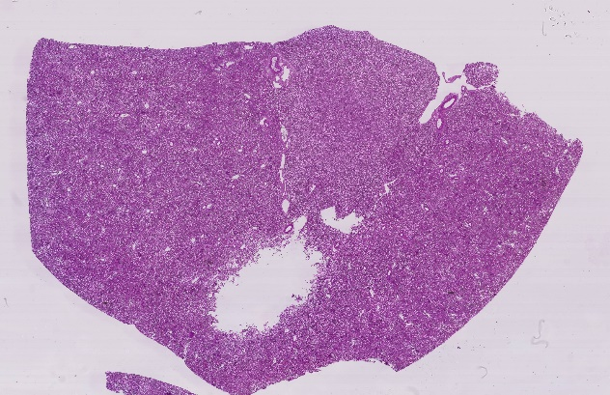

UUID: VAN0006-LK-4-33 VAN0006-LK-4-33_HBM984.PMZN.942

Patient #: 68555

Internal #: 110

A, S, R: 76, F, W

Laterality: Left

(Right, Left)

Anatomical Location: Upper

(U, M, L, N/A)

Dimensions: 20 x 14 x 5

(in mm)

Distance from Tumor: N/A

(in cm)

Image:

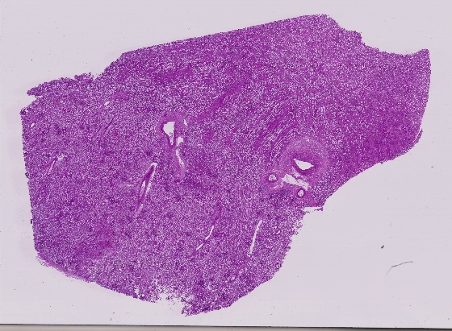

UUID: VAN0010-LK-152-162 VAN0010-LK-152-162_HBM649.DLZF.463

Patient #: 67112

Internal #: 89

A, S, R: 56, M, W

Laterality: Left

(Right, Left)

Anatomical Location: Lower

(U, M, L, N/A)

Dimensions: 25x10x4

(in mm)

Distance from Tumor: 3

(in cm)

Image:

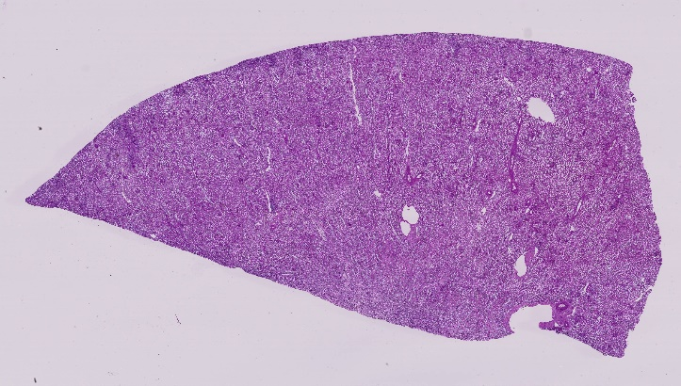

UUID: VAN0029-RK-2-80 VAN0029-RK-2-80_HBM344.LLLV.539

Patient #: 69677

Internal #: 154

A, S, R: 62, M, W

Laterality: Right

(Right, Left)

Anatomical Location: Lower

(U, M, L, N/A)

Dimensions: 24 x 13 x 6

(in mm)

Distance from Tumor: 5

(in cm)

Image:

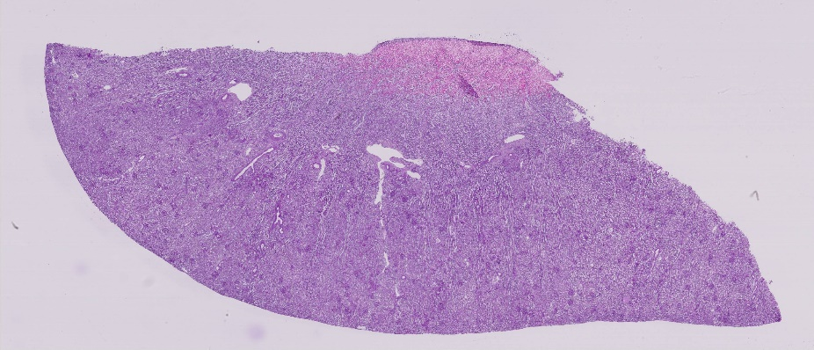

UUID: VAN0031-LK-2-58 VAN0031-LK-2-58_HBM673.JJRZ.435

Patient #: 70194

Internal #: 162

A, S, R: 77, F, W

Laterality: Left

(Right, Left)

Anatomical Location: Lower

(U, M, L, N/A)

Dimensions: 13 x 12 x 11

(in mm)

Distance from Tumor: N/A

(in cm)

Image:

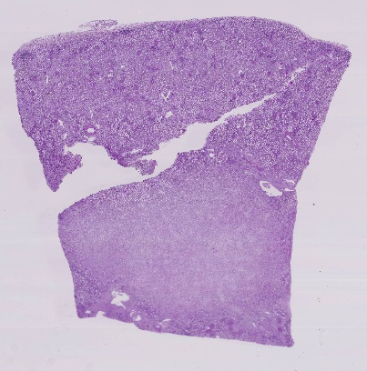

UUID: VAN0032-RK-4-5 VAN0032-RK-4-5_HBM227.THVC.544

Patient #: 70287

Internal #: 164

A, S, R: 66, M, W

Laterality: Right

(Right, Left)

Anatomical Location: Lower

(U, M, L, N/A)

Dimensions: 10 x 10 x 12

(in mm)

Distance from Tumor: N/A

(in cm)

Image:

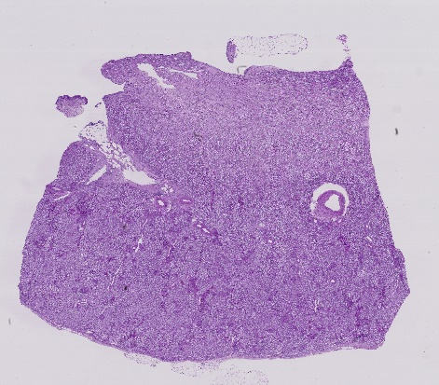

UUID: VAN0032-RK-5-6 VAN0032-RK-5-6_HBM627.RSGW.898

Patient #: 70287

Internal #: 165

A, S, R: 66, M, W

Laterality: Right

(Right, Left)

Anatomical Location: Lower

(U, M, L, N/A)

Dimensions: 16 x 14 x 14

(in mm)

Distance from Tumor: N/A

(in cm)

Image:

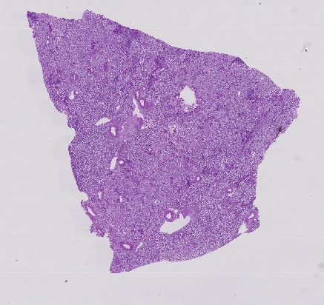

UUID: VAN0034-RK-4-7 VAN0034-RK-4-7_HBM832.FQKR.463

Patient #: 71354

Internal #: 173

A, S, R: 57, F, W

Laterality: Right

(Right, Left)

Anatomical Location: Lower

(U, M, L, N/A)

Dimensions: 19x20x11

(in mm)

Distance from Tumor: N/A

(in cm)

Image:

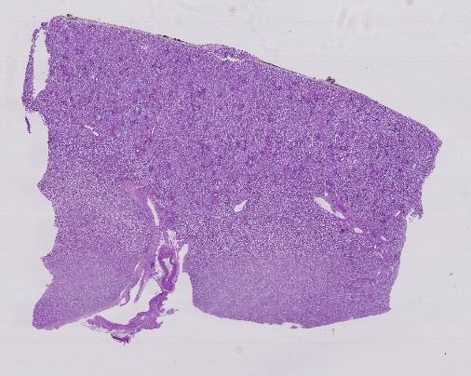

UUID: VAN0034-RK-5-5 VAN0034-RK-5-5_HBM649.XFQG.775

Patient #: 71354

Internal #: 170

A, S, R: 57, F, W

Laterality: Right

(Right, Left)

Anatomical Location: Lower

(U, M, L, N/A)

Dimensions: 25x17x5

(in mm)

Distance from Tumor: N/A

(in cm)

Image:

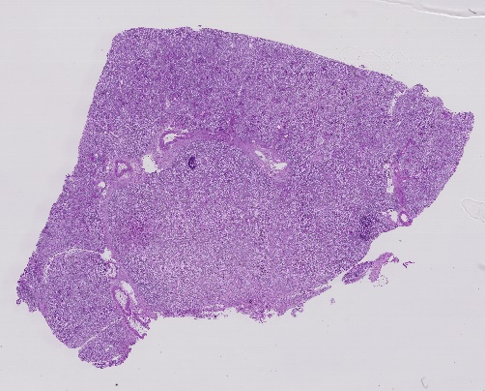

UUID: VAN0034-RK-6-5 VAN0034-RK-6-5_HBM296.RLWW.755

Patient #: 71354

Internal #: 171

A, S, R: 57, F, W

Laterality: Right

(Right, Left)

Anatomical Location: Lower

(U, M, L, N/A)

Dimensions: 26x12x9

(in mm)

Distance from Tumor: N/A

(in cm)

Image:

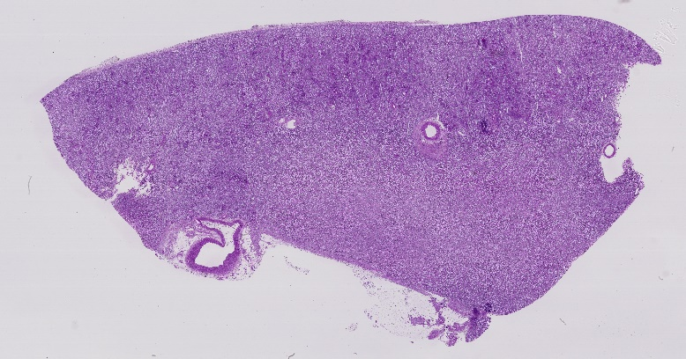

UUID: VAN0034-RK-7-7 VAN0034-RK-7-7_HBM324.ZGZM.874

Patient #: 71354

Internal #: 172

A, S, R: 57, F, W

Laterality: Right

(Right, Left)

Anatomical Location: Lower

Dimensions: 23x18x10

(in mm)

Distance from Tumor: N/A

(in cm)

Image:

